RESOLUTION TO REPEAL KINSEY BASED LAWS

WHEREAS, in the Miller vs California case¹ of 1973, the Supreme Court of the United States has determined that the First Amendment of the United States Constitution does not protect materials which are obscene, defined as
- Materials which taken as a whole, appeal to prurient interests according to contemporary community standards;
- Materials that, according to contemporary community standards as viewed by the average person, depict or describe sexual conduct in a patently offensive way; and
- Materials that a reasonable person finds that, taken as a whole, lack serious literary, artistic, political, or scientific value;

WHEREAS, Dr. Alfred Kinsey’s child “orgasm” Tables 30, 31, 32, 33, and 34, and pages 160-161, etc., in “Sexual Behavior in the Human Male,” report² “9 technically trained” sexual predators abused / raped up to 2,035 children as part of Kinsey’s world-famous “scientific” research;

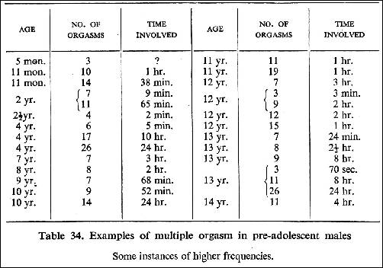

WHEREAS, Federal and states’ subsequent uncritical use and reliance, without peer review or verification, of the data contained in Tables 30-34 and related information in Kinsey’s study to justify:
- Changes in statutory law, including but not limited to the American Law Institute Model Penal Code³ in 1955, which decriminalized or lessened criminal penalties for sexual offenses and provided exemptions to schools and libraries from laws protecting minors from obscene material;
- Changes in educational standards now including books, lectures, films, videos, etc., of explicit and deviant sexual content in courses originally denominated as “sex education” developed by organizations formed at the Kinsey Institute; Sexuality Information and Education Council of the United States (SIECUS) and Planned Parenthood; ⁴

WHEREAS, the State Factor ALEC Report⁵ representing 2,400 lawmakers warned that Kinsey’s frauds harmed women and children, in "Restoring Legal Protections for Women and Children: A Historical Analysis of The States’ Criminal Codes." ALEC documents; "a pornography-addicted, sadomasochistic, bi/homosexual pedophile launched the sexual revolution, reduced sex crime penalties and sabotaged American sex law.” Between 1960-1980 Kinsey’s abnormal sexuality was legally taught to children via health/sex education. "Since then…public health costs from sexual disease and dysfunction have skyrocketed…[all] socio-sexual disorder[s] soared from the 1960s, when protective laws began to be weakened and/or eliminated";

WHEREAS, Texas laws based on fraudulent research by Dr. Alfred Kinsey include affirmative defenses in Texas Penal Code 43.24⁶ for the “sale, distribution, or display of harmful material to minors” for “scientific, educational, governmental, or other similar justification” and the affirmative defenses in Texas Penal Code 43.25⁷ for employing, authorizing, or inducing “a child younger than 18 years of age to engage in sexual conduct or a sexual performance” for “educational, medical, psychological, psychiatric, judicial, law enforcement, or legislative purpose.”

THEREFORE, the State of Texas should repeal all Texas laws based on fraudulent research by Dr. Alfred Kinsey, Plank #103 of the Republican Party of Texas should be replaced as follows:

“Plank #103: Kinsey based Laws: We urge repeal of Texas laws that are based on fraudulent research by Dr. Alfred Kinsey including the affirmative defenses that allows children access to harmful, explicit, or pornographic materials and to be induced into sexual performance under the guise of education materials.”

THEREFORE, LET IT BE RESOLVED, that a copy of this resolution be sent to the ____________________ County/Senate District #_____ Convention Resolutions Committee from Precinct #____ with the recommendation that it be passed and sent to the State Convention Platform Committee of the Republican Party of Texas.

¹ https://supreme.justia.com/cases/federal/us/413/15/
² Alfred C. Kinsey, Wardell R. Pomeroy, and Clyde E. Martin. Sexual Behavior in the Human Male. Philadelphia, Pa: W.B. Saunders: 1948: 610-666
³ https://documentcloud.adobe.com/link/track?uri=urn%3Aaaid%3Ascds%3AUS%3Ac870e143-727d-4bf7-80ef-6e08c0f6271e
⁴ http://www.drjudithreisman.com/archives/2010/12/special_report.html
⁵ http://www.drjudithreisman.com/archives/alec0404.pdf
⁶ https://statutes.capitol.texas.gov/Docs/PE/htm/PE.43.htm#43.24
⁷ https://statutes.capitol.texas.gov/Docs/PE/htm/PE.43.htm#43.25

